Windows User

[Email address]

Abstract

[Draw your reader in with an engaging abstract. It is typically a short summary of the document.   
When you’re ready to add your content, just click here and start typing.]

Large Integer Multiplication

[Document subtitle]

**Python Ord()**

The Python *ord()* method returns the Unicode code of a specific character. This value is represented as a number. You can only use the ord() method on a single character at one time.

For example, say you want to check if each character in a string includes a special character. You could use *ord()* to do this.

The Python *ord()* function accepts one argument: the character whose Unicode code value you want to retrieve. The function returns an integer representing the Unicode code value of the character you have passed into the function.

Here’s the syntax for the ord() method:

**ord**(character)

*ord()* only accepts one character. If you want to run *ord()* on multiple characters, you will need to retrieve each individual character from a string and use *ord()*.

Example:

user_name = "John"

**for** char **in** range(0, len(user_name)):

print(ord(user_name[char]))

Our code returns:

74

111

104

110

**Why do we use the Ord function?**

Since the parameters passed to the multiplication function are strings, it is necessary to store them as characters in an array.

Therefore, the characters need to be converted to integers using the ASCII code

To perform this process requires ord() function

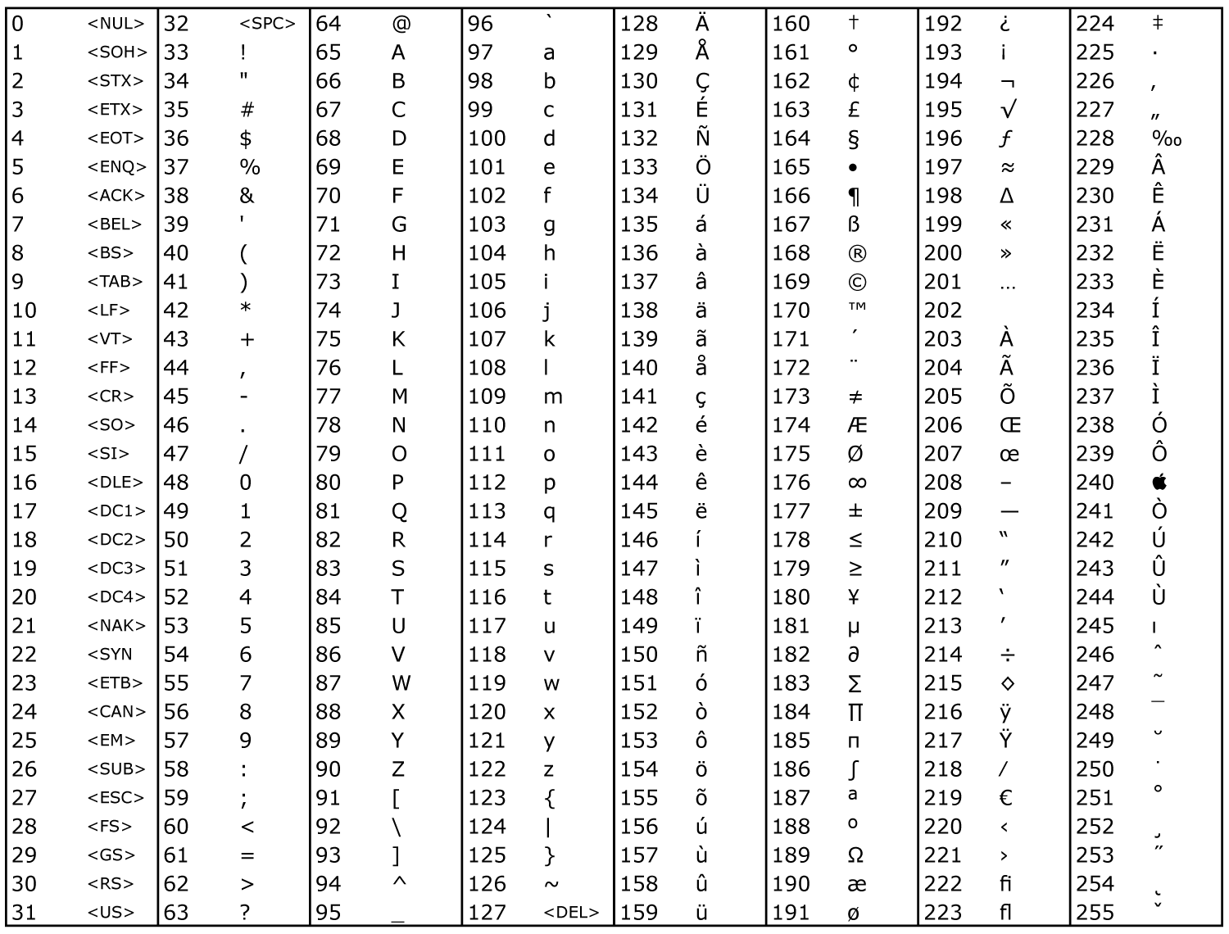

ASCII table